Assessing the effect of model parameter uncertainty on the performance of management strategies in Ecosim

Authors: Mark Platts^{1,4,6} and Steven Mackinson^{3,6}

Development team²: Steven Mackinson, Mark Platts, Joe Buzowski⁴, Jeroen Steenbeek⁴, Carl Walters⁴, Silvia Hadeler⁶, Axel Rossberg⁶, Clement Garcia⁵, Christopher Lynam^{1,5}.

Issue date: 10th May 2017

¹ Contact: Mark Platts (markplatts23@gmail.com) , Christopher Lynam (Christopher.lynam@cefas.co.uk)
² The development team includes all those who have played a role in either the conception, design and implementation of the solutions.
³ Scottish Pelagic Fishermen’s Association (steve.mackinson@scottishpelagic.co.uk)
⁴ Ecopath International Initiative
⁵ Centre for Environment Fisheries and Aquaculture Science (Cefas)
⁶ Formerly Cefas

How to cite this report: Platts, M. and Mackinson, S. 2017. Assessing the effect of model parameter uncertainty on the performance management strategies in Ecosim. Joint Technical report, Cefas and Ecopath International Initiative. 61pp. https://doi.org/10.14466/CefasDataHub.44



Head office
Centre for Environment, Fisheries & Aquaculture Science
Pakefield Road, Lowestoft, Suffolk NR33 0HT, UK
Tel +44 (0) 1502 56 2244 Fax +44 (0) 1502 51 3865
www.cefas.defra.gov.uk

Cefas is an executive agency of Defra

About this report

This report describes the development of a tool for assessing the effect of model parameter uncertainty on the performance of management options simulated using an ecosystem model. It provides the rationale, description of methods and algorithms, and a step-by-step guide for users of the tool. While the interface of the tool is designed to be user friendly, the setup of input files and its application requires a thorough understanding of the parameterisation of Ecopath models, advanced experience with Ecosim and understanding of Management Strategy Evaluation procedures. Mackinson et al. (in prep) provides a demonstration application by evaluating the implications of the North Sea multi-annual plan (EC 2016/0493).

Acknowledgements

The work started in earnest in 2011 and has been supported by funding from the EU Framework 7 (FP7) GAP2 project and from Defra project M1228 ‘Fizzyfish’. This report marks a milestone in the tools’ capability and the foundations for continued development to support evaluations of the ecological and fishery trade-offs associated with alternative fisheries management options.

Contents

Table of Contents
About this report 2
Acknowledgements 2
Contents 3
Table of Contents 3
1. Introduction 5
2. How the tool works 7
2.1. Overview of how the plug-in works 7
2.2. Create possible EwE Models 8
2.2.1 Ecopath Parameters 8
2.2.2 Ecosim Parameters 12
2.3. Evaluate Management Strategies 14
2.3.1 The Management Loop 14
2.3.2 Screening the Results 27
Ideas for future developments for the plug-in are (in order of priority): 28
3. User Guide – Instructions 29
3.1. Create possible EwE models 29
3.1.1 Step 1: Starting up the plug-in 29
3.1.2 Step 2: Creating the file structure 29
3.1.3 Step 3: Configuring the distribution parameters for basic Ecopath input parameters 33
3.1.4 Step 4: Configuring the distribution parameters for basic Ecosim input parameters 34
3.1.5 Step 5: Configuring the survivability distribution parameters 34
3.1.6 Step 6: Editing the diet distribution parameters 34
3.1.7 Step 7: Specify the area that the model represents 35
3.1.8 Step 8: Run the generation of models 35
3.2. Evaluate Management Strategies 35
3.2.1 Step 9: Configure the strategies 35
3.2.2 Step 10: Editing the maximum increase in effort values 39
3.2.3 Step 11: Configuring the stock recruit relationship used for the stock assessment (see section 2.3.1 The Management Loop: Perform stock assessment) 39
3.2.4 Step 12: Setting the observation Error (see section 2.3.1 The Management Loop: Estimate a biomass from scientific surveys – the simulated ‘Survey Biomass’) 40
3.2.5 Step 13: Setting the implementation error (see section 2.3.1 The Management Loop: Add implementation error) 41
3.2.6 Step 14: Setting the quota shares 41
3.2.7 Step 15: Setting up the Biomass Limits (see section 2.3.2 Screening the Results) 43
3.2.8 Step 16: Resolving forcing function issues 43
3.2.9 Step 17: Running the MSE 44
3.2.10 Step 18: Viewing the results 45
3.2.11 Step 19: Plotting and displaying results 47
4. Limitations and assumptions of the tool 53
5. Example and application 54
6. Appendices 54
6.1. Appendix 1. Inventory of input distribution parameter files 54
6.2. Appendix 2. ParametersOut 55
6.3. Appendix 3. Settings for evaluation of management strategies 57
6.4. Appendix 4. Ideas for fleet behaviours 59
6.5. Appendix 5. Symbols for parameters 59
6.6. Appendix 6. Unusual behaviours explained 62
6.6.1 Big drops in efforts 62
7. References 62

Introduction

The need for a tool to assess the effects of parameter uncertainty in Ecopath with Ecosim (EwE) model simulations
An ecosystem model's ability to predict patterns observed in nature depends on having good knowledge of the systems mechanisms and parameters. Because knowledge about the complexities of marine ecosystem processes and the ability to measure them contains gaps and uncertainties, the realism and accuracy of an ecosystem model’s predictions are uncertain. Uncertainty is important to decision makers because they need to know the risks associated with alternative possible management outcomes. By considering the uncertain inputs to a model, we can determine the range of possible outputs and begin to assess the risks of such things as depleted stocks and failing fishing businesses. Furthermore, the methodologies used to evaluate the impacts of uncertainty can be used to determine where the gaps in scientific knowledge have the greatest impact on decision making, and therefore inform where research would be most cost effective.

This plug-in tool was built to help the user assess management strategies robustness to the uncertainties in predictions from ecosystem models developed in the Ecopath with Ecosim software (www.ecopath.org).

Core to the plug-in is the Management Strategy Evaluation (MSE) methodology (e.g. Kell et al. 2007), which addresses the need to provide decision makers with the risks and uncertainties in performance associated with alternative strategies.

The sources of uncertainty that the plug-in is concerned with are model error, observation error, and implementation error.

(1) Model error occurs when the model cannot accurately represent the true system. The two sources of model error are structural uncertainty and parameter uncertainty. Here we only deal with parameter uncertainty. It is important to take parameter uncertainty in to account for as many model inputs as possible, because any parameter not included will in most cases, cause an underestimation in the uncertainty in the results.

(2) Observation error arise from imperfect fish stock surveys, which produce inaccuracies in the estimates for fish stock biomasses.

(3) Implementation error arises through the inability to accurately predict what the actual fishing effort will be for a fleet.

Question: Why build a plug-in when EwE already has built-in functionality to perform Management Strategy Evaluation (MSE)?

There are several reasons:
- The MSE functionality already present within EwE does not assess the effect of model parameter uncertainties. It only represents uncertainties in a management procedure loop.
- We wanted a tool with an interface that is as simple as possible, oriented for use with fishery managers and stakeholders, and focussed on tools to address their needs.
- Because our needs are different we did not want to compromise functionality of the existing routine. While independent, several elements of the existing routine are used.
- We wanted a tool that is accessible to other internal routines that may benefit from this development.
- To provide a tool that we are able to develop as needs and thinking evolves.

How the tool works

Overview of how the plug-in works

The plug-in has two main stages of execution (Figure 2.1).
Figure 2.1. Flow chart showing an overview of the two main stages of the plugin

Stage 1. Create possible EwE Models – uses user-specified probability distributions to sample all parameters of which each model is comprised, and saves them to disk.

Stage 2. Evaluate Management Strategies (Figure 2.2) gets input from the user about Harvest Control Rules, Discards Policies, Quota shares for each fleet, Number of Years to Project, Observation and Implementation Errors, Maximum fractional increase in effort, Biomass limits. Applying these settings, Ecosim is then run for all selected combinations of strategies and models created in stage 1, and providing the results are plausible, they are saved to disk.

Figure 2.2 Flowchart for the evaluation of management strategies

Create possible EwE Models

Ecopath Parameters

Mass-balance criteria
An important criteria for a valid base Ecopath model is that it is mass-balanced (for further details consult the Ecopath literature and help files). The three criteria used for determining this are:

- Ecotrophic efficiencies are on the interval [0,1]
- Respirations must be positive
- The p/q ratios must be less than 0.5

These criteria are dependent on the combined values of the Basic Ecopath parameters and Diet Composition matrix. Therefore the entire set of these values must be sampled together before the criteria are tested. Each time the criteria fails, the parameters are sampled and tested again, until a set of parameters that pass is obtained.

Because Ecopath models rely on mass-balance, one missing parameter for each functional group can be determined if all of the remaining parameters are known. Consequently when a user configures an Ecopath model they must leave one parameter free for each functional group. When the plug-in comes to estimating this parameter, no value is sampled but instead it is calculated by solving the mass-balance equation.

Sampling the Basic Ecopath Parameters
The Ecopath parameters biomass, biomass accumulation, ecotrophic efficiency, production/biomass and consumption/biomass are all sampled from a user-specified truncated normal distribution. A truncated normal distribution is used because in most cases these parameters can be estimated and a normal distribution closely approximates the error around the estimation. Sampling of these parameters is done using a rejection method, whereby samples are taken from a normal distribution and any sample beyond an upper and lower limit is rejected. To specify this distribution the user must designate the mean and coefficient of variation (CV) for the normal distribution that is to be truncated, along with the upper and lower limits.

Note that the standard deviation of the distribution for the parameter is the sampled parameter value * CV. To understand why the CV is used, consider the Biomass of two species. If one has a small mean while the other is really big, would the same absolute error be equivalent? Often what we want is an error or uncertainty that is proportional to the size of the means. This is what CV does. CV=SD/mean. And so if for example SD doubles and the mean doubles the CV stays the same.

Sampling the Diet Matrix
The uncertainties in the diet compositions are specified using Dirichlet distributions. The Dirichlet distribution is an appropriate distribution because it is a multivariate distribution where each element is sampled on the [0,1] interval and together they all sum to 1. Each predator has its own Dirichlet distribution parametrised using a number of parameters equal to the number of groups that it preys upon. Each parameter is calculated as the expected (mean) proportion that a prey will make up of its diet, multiplied by a multiplier. Increasing the value of the multiplier serves to decrease the dispersion around the expected proportions.

Figure 2.3 shows plots of what the marginal probability densities (multidimensional probability distributions plotted along one dimension) would be for a predator with three prey A, B & C where the mean proportion for each prey respectively is 0.6, 0.3 and 0.1. The plots show how by increasing the multiplier κ the dispersion around the means can be decreased. To determine an appropriate κ for each predator it is best to plot the Dirichlet distributions in this way, viewing them to consider which κ provides the right amount of uncertainty across as many prey groups as is possible.

Due to numerical issues when using the diet proportion values, any values that are sampled below 0.000001 are set to zero. This has little impact on the results.

Figure 2.3. Plots showing how varying the multiplier affects the dispersion of the distribution for each prey proportion.

Ecosim Parameters

Sampling the Basic Ecosim Parameters
The Basic Ecosim parameters that are sampled are density dependent catchability, feeding time adjustment rate, max relative feeding time, fraction of other mortality sensitive to changes in feeding time, predator effect on feeding time, QBMax/QBo and switching power. One of two distributions can be used to define the parameter range for each functional group; (1) a uniform distribution or (2) a triangular distribution. In many cases very little will be known about the value of these parameters, making the uniform distribution an appropriate distribution where we only know the possible limits of a parameter. Often these limits will be the point beyond which the value would be nonsensical, for example zero, where the parameter cannot be negative. For cases where more is known about the central location of a parameter the triangular distribution can be used.

The lower and upper bound for the uniform distribution parameters are specified directly by the user and the Ecosim parameters are sampled from this distribution using Equation 2-1.

$$x=a+U(b-a)$$ | Equation 2-1

Where x is the sampled parameter, a is the lower bound, b is the upper bound and U is a random variable with a standard uniform distribution.

Triangularly distributed parameters are sampled using Equation 2-2.

$$x=\left\{\begin{matrix}a+\sqrt{U(b-a)(c-a)} \\ b-\sqrt{(1-U)(b-a)(b-c)}\end{matrix} \begin{matrix}if U<\frac{c-a}{b-a} \\ if U≥\frac{c-a}{b-a}\end{matrix}\right.$$ | Equation 2-2

Where a is the lower bound, b is the upper bound, c is the mode.

Discard Survival Proportion
The Discard Survival Proportion is the proportion of discards that survives and returns back into the catchable biomass pool. Inside EwE this value is used to set what is known as the ‘discard mortality rate’ (but a more accurate name is ‘proportion of discards that die’):
$$m_{d}\left(i,j\right)=1-s(i,j)$$ | Equation 2-3

Where m_{d}(i,j) is the proportion of discards that die for functional group i when caught by fleet j and s(i,j) is the survivability for the same functional group and fleet.

The discard survival proportion is sampled from a Beta distribution specified by the user through two parameters, P and Q, which define a unique distribution for each functional group caught by each fleet. This provides for great flexibility as data on the differences in species survivability to discarding becomes more prevalent. Note that the ‘discard mortalities’ specified within the base EwE model, will be overwritten by the plug-in's proportion of discards that die.

The mean of the beta distribution is a function of the ratio Q/P:
$$μ=\frac{1}{1+\frac{Q}{P}}$$ | Equation 2-4

And the variance is:
$$σ^{2}=\frac{PQ}{{\left(P+Q\right)}^{2}(P+Q+1)}$$ | Equation 2-5

This means that P and Q can be changed and provided that the ratio between P and Q remains the same the mean will remain the same, while the variance changes.

Alternatively, users can specify directly the proportion of species discarded by each fleet that survive (via the ‘survivabilities.out’ file)

Vulnerabilities
Vulnerability parameters are sampled for all possible interactions, that is for any two functional groups. Because little is known about what the value should be for any possible vulnerability parameter, all parameters are sampled from the full possible range using Equation 2-6 (Gaichas et al. 2012).

$$v_{rk}=1+e^{9(U-0.5)}$$ | Equation 2-6

Where r is the predator, k is the prey.

Evaluate Management Strategies
The flow chart in Figure 2.2 gives an overview of how the ‘Evaluate Management Strategies’ part of the plug-in works. The sections that follow explain the ‘Management Loop’ and ‘Saving the Results’ components in more depth. It is suggested that the reader studies the flow diagram prior to reading the following sections; this will help in understanding how the various components fit together.

The Management Loop

Estimate a biomass from scientific surveys – the simulated ‘Survey Biomass’
At the beginning of the year the average biomass predicted by the model over the previous 12 months is calculated. Observation error sampled from a log-normal distribution parametrised using a user specified coefficient of variation is then added to this, giving an estimate of biomass at the beginning of the year. This is the simulated Survey Biomass.

Perform stock assessment
The purpose of the stock assessment is to provide an estimate of stock size, determined from the simulated survey biomass and prediction of recruitment. The results of complex assessments (which are not practical to simulate for multiple functional groups in the Ecosim MSE framework) are simulated by approximating the results of stock assessments as a weighted average of the predicted biomass and biomass estimated from surveys (Walters 2004, equations 1-6):

$$B_{t|t}=B_{t|t-1}+K_{t}^{*}(B_{t}^{*}-B_{t|t-1})$$ | Equation 2-7

Where $B_{t|t}$ the best (minimum variance) estimate of $B_{t}$ given all of the data up to time t, $B_{t|t-1}$ is the best prediction of $B_{t}$ given only the data up to time t -1, $K_{t}^{*}$ is the Kalman gain and $B_{t}^{*}$ is the simulated “Survey” biomass at time t. The prediction ($B_{t|t-1})$ comes from Schnute’s generalization of the original Deriso model (Schnute, J. 1985), with a simplified representation of biomass dynamics:

$$B_{t|t-1}={gB}_{t-1}e^{-FishMort-NatMort}+wR_{t}$$ | Equation 2-8
$$g=\max_{}{\{0,e^{\left(\frac{Ecopath_BA}{Ecopath_B}\right)}-RecruitOverPop\}}$$ | Equation 2-9

Where g is the growth rate, Ecopath_BA is Ecopath biomass accumulation, Ecopath_B is the Ecopath Biomass, RecruitOverPop (Recruitment/total population in the interface) is the percentage of total population that will recruit, and $wR_{t}$ is the biomass recruited estimated using the Beverton-Holt Stock Recruit model:

$$wR_{t}= \frac{α×S_{t-1}}{β+S_{t-1}}$$ | Equation 2-10
$$α=RecruitOverPop×Start Biomass×RatioBt$$ | Equation 2-11
$$β= RatioBt×Start Biomass$$ | Equation 2-12
$$S_{t-1}=B_{t-1}e^{-Z_{t-1}}$$ | Equation 2-13

Where RatioBt (Ratio Bt/Ecopath B for 50% recruitment in the interface) is the Ratio of biomass at time to Ecopath base biomass for 50% of recruitment and RecruitCV (RecruitmentCV in the interface) is the coefficient of variation of the actual recruits around the predicted recruits from the stock recruit model.

The Kalman gain is the proportion that the predicted biomass variance (Var(B_{t|t-1}) is of the total predicted and observed biomass variances:

$$Var(B_{t|t-1})=\frac{{(RecruitOverPop×RecruitCV)}^{2}}{1-g^{2}}$$ | Equation 2-14
$$K_{t}^{*}=\frac{Var(B_{t|t-1})}{Var(B_{t|t-1})+Var(B_{t}^{*})}$$ | Equation 2-15

To understand what the Kalman filter does intuitively, think about what happens when $K_{t}^{*}$ is small, a consequence of the prediction error (variance) being small in comparison to the observation error (variance). In this case there is greater confidence in the prediction than the observation. By making $K_{t}^{*}$ in the equation for $B_{t|t}$ small, we are effectively setting $B_{t|t}$ to be much closer to the prediction rather than the survey biomass. Conversely, when the variance is much bigger for the prediction than the observation, $B_{t|t}$ will be much closer to the observed biomass. To summarise simply, the Kalman filter calculates best (minimum variance) estimate of $B_{t}$ as an average of both the simulated survey and biomasses predicted by the stock assessment, weighted by their variances.

Determine the quota using the Harvest Control Rule (HCR)
(See 3.2.1 Step 9: Configure the strategies)

A quota is determined by multiplying assessed stock size (above) by a landings mortality rate. Harvest control rules define the instantaneous landings mortality (given as Target Fishing Mortality in Figure 2.4 & Figure 2.5) to be applied to a functional group at a given level of biomass of either (i) the target functional group in the case of a Target HCR, or (ii) a different functional group in the case of a Conservation HCR (see below for detail). An example Target HCR can be seen in Figure 2.4.

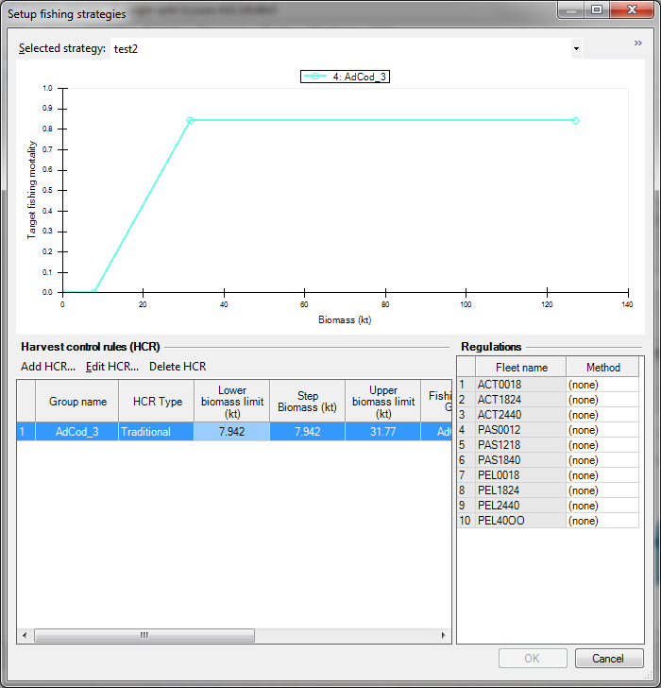
Figure 2.4. Example harvest control rule

A quota is determined for each functional group that has an HCR. To do this the biomass estimated from the stock assessment is used to determine the instantaneous landings mortality rate, F (Equation 4) where B_{i} is the Biomass for functional group i, B^{min} is the biomass at which the F from the HCR reads zero and B^{max} is the Biomass at which the F is equal to F^{max}_{i}, the maximum F). This F is then converted into a quota, by multiplying it by B_{i}. A further step is required to obtain each fleets quota of the functional group; multiply the functional group’s quota by the proportion of the quota each fleet obtains. These proportions are configurable by the user (see 3.2.7 Step 14: Setting the quota shares) but the default values are taken from the proportions of the total landings each fleet lands in the final time step of the hindcast.

$$F_{i}=\left\{\begin{matrix}0 \\ (B_{i}-B_{i}^{min})/(B_{i}^{max}-B_{i}^{min})×F_{i}^{max} \\ F_{i}^{max}\end{matrix}\right. \begin{matrix}B_{i}<B_{i}^{min} \\ B_{i}^{min}<B_{i}<B_{i}^{max} \\ B_{i}^{max}<B_{i}\end{matrix}$$ | Equation 2-16

HCRs can be specified as:

Target HCRs: these are HCR's as they are typically thought of, and are used to determine an F given the biomass of a functional group. From this a quota is calculated.

Conservation HCRs: these are a little different in that while they are used to calculate a quota, this quota is not a quota that is allocated to a fleet directly. Instead the quota calculated is best thought of as a limit to the actual quota. So if the quota from a target HCR is above the quota from the conservation HCR the conservation quota will be used instead. In most cases it is envisaged that the conservation HCR will have different functional groups for the biomass and the F. This will enable the HCR to be set to limit fishing based on the biomass of a non-commercial species; for example, when the biomass of a protected species falls below a give biomass, the F of one or more commercial species is lowered or set to zero.

There is also the option to specify a more complex HCR which here we have given the name Multi-level HCR (Figure 2.5). Multi-level HCRs allow a greater degree of flexibility in the shape and therefore relationship between the biomass and fishing mortality calculated. It does this by enabling the specification of a minimum fishing mortality as well as a biomass level known in the plugin as the “Biomass step” at which the F steps down to the minimum fishing mortality.

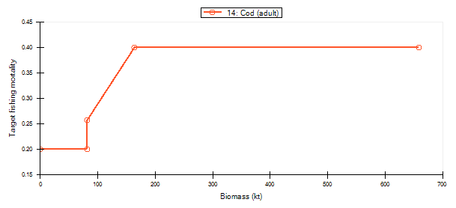
Figure 2.5. An example of a multi-level HCR.

Specifying non-target groups

A non-target groups is a group that a fleet does not target commercially and can be discarded regardless of whether there is a non-discard policy in place or not. This has slightly different effects dependent on the regulation method applied.

Weakest Stock: Non-target groups do not limit the effort applied i.e. it is never a choke species). Non-target groups catches are all discarded.

Highest Value: Non-target groups are never considered when determining the highest value group. All non-target group catches are discarded.

Selective: Non-target groups are never considered when determining the highest value group. Fleets never alter their catchability for this group to avoid it, but instead continue to catch it as previously, and discard all catches.

Non-target groups are groups for which the fleet quota share is set to zero. Note that:
- the values for the quota shares across a species need to sum to one.
- species will only be considered non-target for the forecast period, not the hindcast period.
- setting species to non-target will not affect the outcome for fleets with a “none” regulation method.

Time Frame Rules

Sudden drops in quota allocated to a fleet are recognised as undesirable and to ameliorate this fisheries managers often apply changes in quota gradually over a number of years. Time frame rules enable us to apply such gradual changes. They override the method above for calculating the target F by calculating F’s that step towards the HCR F calculated above over a user-specified number of years.

The time frame rule F is calculated as follows:

$$F_{i}={Init}_{F}-\frac{{Year}_{i}}{Nyears+1}({Init}_{F}-HCR_{F})$$ | Equation 2-17

Where $HCR_{F}$ is the F from the HCR, $NYears$ is the number of years for which the time frame rule should be applied, ${Year}_{i}$is the number of years into the forecast, and ${Init}_{F}$is the actual average F over the last year of the hindcast.

Note:
- If ${Init}_{F}$is less than the HCR F then time frame rule is disregarded and instead the HCR F is used.
- The F calculated is not the actual F applied but as with a HCR the F calculated is used to calculate the quota; usually this is different to the quantity caught over a year.
- At the end of the number of years for which the time frame is specified, the plugin then reverts back to using the HCR to calculate the quota as before.
- Because HCR F can often change with biomass, and therefore is potentially a dynamic value, the changes in one year will often be different from the change in another.
- If you want to arrive at the HCR F by year X, set the time frame rule to X-1 years.
- By default the time frame rule for all HCR’s is set to zero, meaning no time frame rule applies.
- A timeframe rule of 1 means that there will be an intermediate step between the F at the end of the hindcast and the HCR F.

Determine max effort for the year
At the beginning of each year the maximum effort is calculated for the relative effort of each fleet. These values are used to limit how much the effort can increase within a year from the effort as it was at the last time step of the previous year. If an effort calculated throughout the year breaches the maximum effort, the maximum effort is used instead. The maximum effort for the current year is calculated using Equation 2-18:

$$l_{j}^{max}=l_{j}^{prev}+l_{j}^{prev}×λ_{j}$$ | Equation 2-18

Where $l_{j}^{prev}$is the effort at last time step of the previous year for fleet j, $λ_{j}$ is the maximum percentage increase in the effort and $l_{j}^{max}$ is the maximum effort. To avoid numerical issues $λ_{j}$ may only be set to a maximum value of 0.9, and any value greater than this will be set to 0.9.

Determine relative effort and discard rates according to regulations
Regulations are settings that can be applied uniquely to each fleet. Through them we specify whether discarding is allowed or not, as well as how we expect the fleet to behave in response. To better understand them take a look at each of the different regulation settings and consider their differences:

‘NONE’

Description:
This does not actually represent a method of regulation, but rather the absence of one. Fleets which have this setting will not be affected by quotas and will continue to fish at the same rate that they fished at the end of the previous year. It can be used as a ‘Status Quo’ policy to compare with alternative options. Note that this is an option for fleets that catch a species with a configured HCR, however fleets which do not catch any species with an HCR will behave as if they have (none) set as their method of regulation.

Step-by-step explanation:
- Maintain effort at the level it was at the final time-step prior to the projection.
- Set the proportion landed to the proportion in the EwE model
- Set the proportion surviving being discarded to the value sampled for the current model (see 2.2.2 Ecosim Parameters: Discard Survival Proportion)

‘Weakest stock’

Description:
The weakest stock regulation method is intended to represent a strict no-discards policy. The effort required to catch 1/12th of the quota of each species is calculated each month (each time step) and then set equal to the minimum effort value calculated (the effort required to catch the ‘weakest stock’), which ensures that none of the quotas will be exceeded throughout a year. Which species is the weakest stock depends on the biomass each month and therefore in some cases may change over the course of a year. The fleet has no ability to alter its catch composition (i.e. unselective), which means that the species that requires the least effort to fulfil its quota becomes the bottleneck or ‘choke species’ that determines the amount of effort deployed. Note that non-target species are exempt from being a ‘choke species’. Presently, discards are allowed for fish below minimum size if they have been specified in the basic Ecopath model.
Step-by-step explanation:
For each fleet that has a quota for at least one functional group:
- Cycle through each functional group for which the fleet has a quota and calculate the effort required to catch the functional group's quota

$$E_{j}^{T}=\frac{q_{i,j}q_{i}^{T}}{M_{i}F_{i,j}B_{i}}$$ | Equation 2-19

Where $E_{j}^{T}$ is target effort, q is the quota share, $q_{}^{T}$ is the target quota, $M_{i}$ is the density dependent catchability multiplier at current timestep, $F_{i,j}$ is the fishing mortality, $B$ is the biomass.
- And also the effort required to catch up to the quota from a conservation F

$$E_{j}^{C}=\frac{q_{i,j}q_{i}^{C}}{M_{i}F_{i,j}B_{i}}$$ | Equation 2-20

Where $E_{j}^{C}$ is the conservation effort, $q_{i}^{C}$ is the target quota.
- If the conservation effort is less than the target effort then use the conservation effort, otherwise use the target effort.
- From all the efforts calculated for a fleet, apply the lowest to the current time-step. By applying the lowest we ensure that the main objective of this regulation is achieved, to never catch beyond the quota of any functional group.
- If the effort is outside the upper effort limit reset the effort to the upper limit (see section Determine relative effort limits for the year)
- Set the proportions landed and discarded to the proportion in the EwE model
- Set the proportion surviving being discarded to the survivability value sampled for the current model

‘Highest value’

Description:
The highest value regulation is a policy where it is assumed that the fleet will catch the entirety of the highest valued quota. The highest value quota in the fleets’ portfolio is calculated at the beginning of each year based on quota and price. The effort required to ensure that the quota of the highest value species in their portfolio is fully utilised by the end of the year is spread equally across the months. If the quotas of other stocks are fulfilled during this time, any fish caught above quota are discarded.

Step-by-step explanation:
For each fleet that has a quota for at least one functional group:
- Determine which functional group has the highest value quota (where highest values = price x quota)
- Calculate the effort that would land the quota

$$E_{i,j}^{T}=\frac{q_{i,j}q_{i}^{T}}{m_{i,j}^{l}M_{i}F_{i,j}B_{i}}$$ | Equation 2-21

Where $E_{i,j}^{T}$ is the effort to catch the target quota and $m_{i,j}^{l}$ is the proportion of the catch that is landed and i is the index of the highest value group.
- Calculate the effort required to catch the conservation quota for this highest value group if a conservation quota exists:
$$E_{i,j}^{C}=\frac{q_{i,j}q_{i}^{C}}{m_{i,j}^{l}M_{i}F_{i,j}B_{i}}$$ | Equation 2-22

- Let $E_{j}=\min_{}\left(E_{i,j}^{T}, E_{i,j}^{C}\right)$
- If the effort is outside the upper and lower limits reset the effort to the breached limit (see section Determine relative effort limits for the year)
- For each functional group for which the fleet has a quota:
  - Estimate the catch if the fleet was to fish at the current level for 12 months
$$C_{i,j}=E_{j}M_{i}F_{i,j}B_{i}$$ | Equation 2-23
  - if the Catch is greater than the smallest quota from either the conservation and target HCR/prop landed as set in EwE then
    - Set the proportion landed to quota/catch
    - Set the proportion surviving being discarded to the value sampled for the current model
  - If the catch is not greater than the smallest quota
    - Set the proportion landed to the proportion in the EwE model

5.3 Difficulties combining the dynamic discarding of the plugin with the static discarding of the EwE
Note that there are some inaccuracies in the proportions of the catch discarded. These inaccuracies are rooted in the discard proportions specified in the EwE model, the discard proportions calculated by the plug-in and the problem of combining them. There are various reasons that a fleet discards: no remaining quota, undersized catch and high-grading being the most significant causes. The values in the EwE model specify as a fixed value the proportion discarded for all these reasons. The plug-in builds on this by calculating the discards dynamically, however this calculation is only of the discards due to no remaining quota. This gives two discard rates but choosing how to use or combine them is problematic. Using each alone means that either there is a constant discard rate or there is a discard rate that represents only catches beyond the quota. Furthermore, it is not possible to combine these two values without additional information; adding the EwE Model discard rate to the discard rate calculated by the plug-in would mean that we would be accounting twice for catch with no remaining quota and therefore the discard rate when fishing beyond quota would always be too great. The ideal solution to this problem would be to separate out from the EwE model discard rate the proportion of the discard rate that is due to reasons other than being beyond quota, and at present we do not have the information to do this.
Instead a less-than-ideal, but pragmatic solution has been used; in cases where the catch across the year will be less than or equal to the quota, the EwE Model discard rate is used, and in cases where the catch across the year will be beyond the quota, the discard rate as calculated from the plug-in will be used instead. This has the effect of over estimating and underestimating the discard rate respectively. In further work, we hope to address this issue and enable the more satisfying means of combining the EwE model discard rate with the rate from the plug-in.

‘Selective Fishing’
Description
The selective fishing policy specifies a no-discard policy, which mimics the fleet being able to avoid catching species beyond their allocated quota, by whatever means. Fleets target the highest value quota (as above) and can continue fishing until this species’ quota is exhausted. The ability to be selective only applies to species that have an HCR. Therefore if avoiding the catch of a species that does not typically get assigned a quota is desired, then a HCR with a zero F must be applied to the species.

Step-by-step explanation:
For each fleet that has a quota for at least one functional group:
- Determine which functional group has the highest value quota
- Calculate the effort that would land the highest value quota

$$E_{i,j}^{T}=\frac{q_{i,j}q_{i}^{T}}{m_{i,j}^{l}M_{i}F_{i,j}B_{i}}$$ | Equation 2-24

- Calculate the effort required to catch the conservation quota for this highest value group if a conservation quota exists:

$$E_{i,j}^{C}=\frac{q_{i,j}q_{i}^{C}}{m_{i,j}^{l}M_{i}F_{i,j}B_{i}}$$ | Equation 2-25

- If conservation quota exists:
$E_{j}=\min_{}\left(E_{i,j}^{T}, E_{i,j}^{C}\right)$ else $E_{j}=E_{i,j}^{T}$ | Equation 2-26
- If the effort is outside the upper and lower limits reset the effort to the breached limit (see section Determine relative effort limits for the year)
- For each functional group for which the fleet has a quota:
  - Estimate the catch if the fleet was to fish at the current level for 12 months
$$C_{i,j}=E_{j}M_{i}F_{i,j}B_{i}$$ | Equation 2-27
  - if the Catch is greater than the smallest quota from either the conservation and target HCR/prop landed as set in EwE then
    - Set the proportion landed to quota/catch
    - Set the proportion of the catch that is discarded and dies to:
$$m_{i,j}\left(d\right)=(1-m_{i,j}^{l})×\frac{C_{i,j}^{L}}{C_{i,j}^{S}}×(1-s_{i,j})$$ | Equation 2-28

Where $m_{i,j}\left(d\right)$ is the proportion of the catch that dies, $C_{i,j}^{L}$ is the catch required to land the quota, $C_{i,j}^{S}$ is the catch that would have been caught if the fleet had not altered its mortality rate by being selective.
Note: The equation for the ProportionCatchDying has the effect of making the difference between the actual catch and CatchifNotSelective to all be discarded and survive, essentially as if it had never been caught. This is not an intuitiveapproach, but accurately represents the fleet completely avoiding catching a species once it has landed its entire quota.

  - If the catch is not greater than the smallest quota from either the conservation and target HCR/prop landed as set in EwE then
    - Set the proportion landed to the proportion in the EwE model
    - Set the proportion surviving being discarded to the survival proportion sampled for the given model.

Note that in all these cases the quota is the quota as calculated at the beginning of each year; it is not the remaining quota after catches and therefore does not decrease throughout the year. Consequently the relative effort calculated using this quota is the effort that will, based on the biomass and density dependent catchability at the current time-step, catch a proportion of 1/(number of time steps in a year) of the quota; when a time-step is a month in duration this is a 1/12th of the quota. With the exception of one circumstance, applying these calculated efforts at each time-step throughout the year will catch the entire quota. The exceptional circumstance is the instance in which the effort is unable to adequately change due to the maximum or minimum change in the effort, and so the fleet either catches too much or too little of the species in question.

‘No Fishing’
Setting a fleet to be regulated by this method, sets the fleet to not fish at all throughout the entire projection period. The method for applying this is the simplest of all the regulation methods; it sets the effort for this fleet for all projection time steps to zero.

Add implementation error
Typically the historic difference between catch and quota is used to set implementation error as a proxy. Since fleet behaviour, the regulation settings, conservation quota’s and limits to changes in effort already represent many of the mechanisms that create implementation error, this feature except in rare cases is redundant and therefore, we advise the use of a default value of zero. This mechanism exists because it came with legacy code used to build various other features into the plugin.

Implementation error alters the effort applied by sampling it from a log-normal distribution with a mean of the effort calculated thus far and a coefficient of variation as specified by the user. Note that the implementation error is added to the effort after effort limits are applied and because of this the effort can be greater than the maximum effort limits as well as less than quotas and discarding policy would allow. Also the relative error is sampled once each year and applied to the effort calculated each time step throughout the year.

Handling applied forcing F time series’

Because forcing F time series’ are only applied across the hindcast and abruptly stop at the beginning of the forecast a problem is created. The problem is that the forcing F values cannot be created by multiplying the baseline catchabilities by any combination of fleet efforts. The reason for this is that the forcing Fs commonly reflect changes in the catchabilities and therefore the baseline catchabilities multiplied with the efforts no longer align with them. To solve this problem up-to-date catchabilities must be estimated, but to do this we must make an assumption about how the forced F is partitioned into fleet Fs. The assumption made is that:

$$F_{i,j}^{*}=\frac{F_{i,j}}{\sum_{j}{F_{i,j}}}F_{i}^{T}$$ | Equation 2-29

Where $F_{i,j}^{*}$ is the partial F which is used to determine the up-to-date estimate of catchability, $F_{i,j}$ is what the F would have been on group i by fleet j if the effort at the last time step of the hindcast was applied with the baseline catchability and $F_{i}^{T}$ is the F at the forcing F at the last time step of the hindcast.

Since we can now calculate landings and discards on a per fleet basis, updated catchabilities can now be calculated using:

$$q_{i,j}=\frac{L_{i,j}+D_{i,j}}{B_{i}E_{j}}$$ | Equation 2-30

Where q is the catchability, L and D are the landings and discards respectively of the last time step of the hindcast, B is the biomass at the last time step of the hindcast and E is the effort at the last time step of the hindcast.

Note that the effort time series output as results are not calculated and changed when a forcing F time series is applied. Consequently, it will appear as if the cause for any variations in F throughout the forced F time series will be due only to variations in q. In most cases this will not be desirable and therefore the onus is on the user to specify a meaningful effort time series, or otherwise to at least take note that the effort time series in this case will be meaningless.

Issue using discard time series
Generally it is not advisable to use a discard mortality or discard proportion time series when using the MSE Plugin. This is particularly the case when the time series is for a group for which you have specified a HCR. This is because the MSE Plugin calculates the discards proportions dynamically according to the catch and the quota for a year, and this is liable to conflict with the discard time series. If you do attempt to run the plugin while applying a discard time series you will be asked whether you are sure you want to continue running the plugin. If you are sure that there will be no conflict at this point you can choose to do so.

Screening the Results

For a description of the results see User Guide 3.2.11 Step 18: Viewing the results

Before the results of a model are saved to file, a test is performed to check whether the results are plausible. For this the biomass trajectories are checked to be within some user-specified upper and lower bounds. Any model that contains any functional group with a biomass at any time step outside these bounds has its results discarded (unless the user has specified to have all results output for diagnostics purposes).

Ideas for future developments for the plug-in are (in order of priority):

Functionality
- Using a bolt-on approach develop alternative regulatory strategy components to reflect possible responses to banning discarding.
  - Develop a mechanism that will enable investigation of the impacts of uplift (extra quota given to prevent discards).
  - Enable quotas to be of combined species

- Make more sophisticated and flexible the behavioural response of fleets (Appendix 6.4. )
- Allow the discard rates to be specified separately from what they are within EwE and make it explicit that the rate is not for catch beyond quota, this is calculated dynamically within the plugin. See 2.3.1 The Management Loop: Determine relative effort and discard rates according to regulations.
- Allow the parameter distributions to be conditioned on data using a Bayesian approach.

Interface
- Interface to view the results from within Plug-in (At present R-script is used to handle the results)
- Improve the interface layout
  - Use a three-tabbed form for stock assessment, observation and implementation error.
  - Use a three-tabbed form for Basic inputs, survivability’s, diets
  - Hide the data-path with a +/- button

Documentation
- Thoroughly comment the code

R code
- Restructure code as an R package

User Guide – Instructions

We can think of the running of the plugin being broken into two parts, where the first part must be successfully completed before the second part can be attempted. The first part is the generation of models and the second part is the evaluation of the performance of each strategy when run on each generated model (Figure 2.1). Each of these parts will be broken down into steps and explained.

- Create possible EwE models (Basic Setup & MSE Models panels)
- Evaluate Management Strategies (Fishing & Run MSE panels)

Create possible EwE models

Step 1: Starting up the plug-in

Before starting up the plug-in, both the Ecopath and Ecosim models must be loaded; after this the MSE Plug-in option will be enabled under the tools menu. In addition all time-series that are to be used with the models should also be loaded. Clicking on Tools → MSE Plug-in (Figure 4.1) will open up the interface.

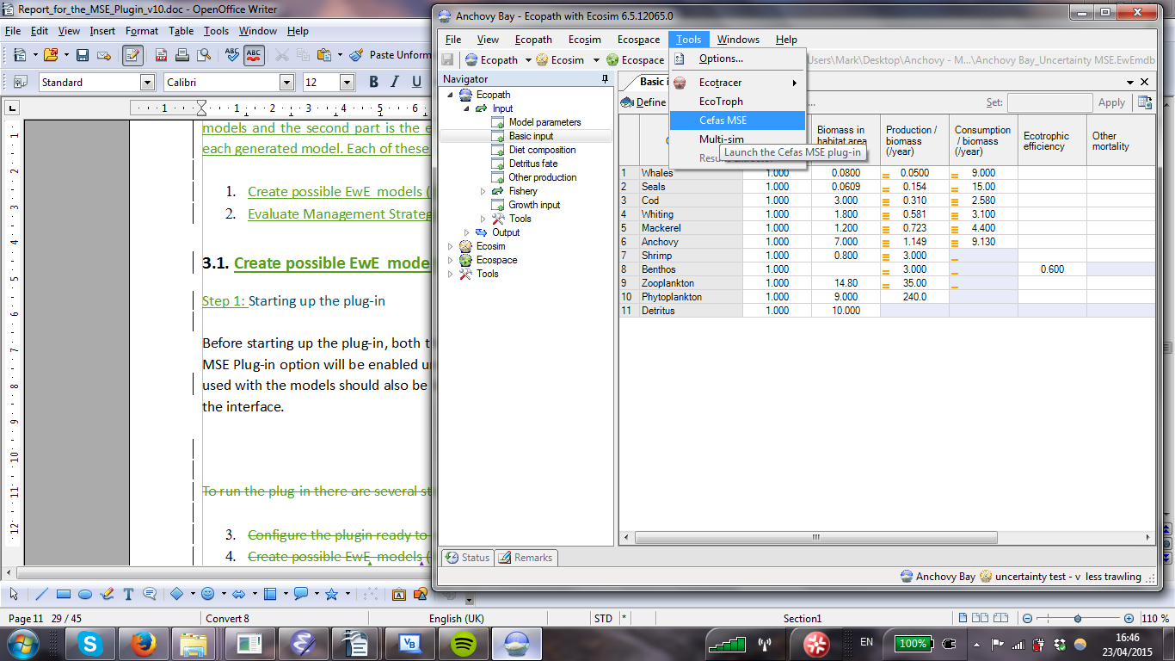
Figure 3.1 Loading the MSE plug-in

Step 2: Creating the file structure

The plug-in stores all the input and output data as comma-separated values (CSV) files. Before distribution parameters can be configured a correct file structure (Figure 4.2)with default data files needs to be set up (see 6.1. Appendix 1. Inventory of input distribution parameter files). To do this, click the on “Select” (Figure 4.3) in the “Basic Setup” panel and browse to the folder where you would like the data folders. If you would like to create a new folder you can do so from this form. Once you have confirmed this path, click on "Basic Inputs” and confirm that you would like a default file structure creating. It is important to emphasise that the default input parameters created for the distribution parameters are not adequate values for running a management strategy evaluation. Default values are provided only for preliminary testing purposes to see that your model will run with the MSE Plugin, before you commit to a full configuration of the MSE Plugin. Careful consideration needs to be given to setting distribution parameter values that represent your uncertainty of the parameters they relate to and where you have no grounds for arguing one value over another, the maximal amount of uncertainty should be applied within a specified range. This range may be the maximum range that makes numerical sense.

Figure 2. Directory Structure

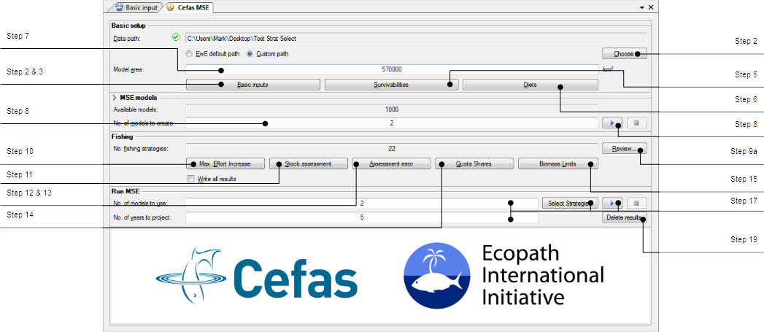

Figure 4.3. The main MSE plug-in form

Step 3: Configuring the distribution parameters for basic Ecopath input parameters

Load the Edit distribution parameters form(Figure 4.4), by clicking on the “Basic inputs...” button. By default the "Model" drop down box should be set to Ecopath, but if it isn't change it so that it is. There are five categories of basic Ecopath input parameters (See 2.2.1 Ecopath Parameters: Sampling the Basic Ecopath Parameters). Start with Biomass and specify for each group the CV, lower and upper bounds to parametrise its truncated normal distribution. The mean for each parameter is the fixed value already specified in the EwE model. Note that this mean will often be different to the actual mean which will depends on the bounds at which the distribution is truncated. After you have completed filling all the values for biomass do the same for biomass accumulation, consumption/biomass, production/biomass and ecotrophic efficiency.

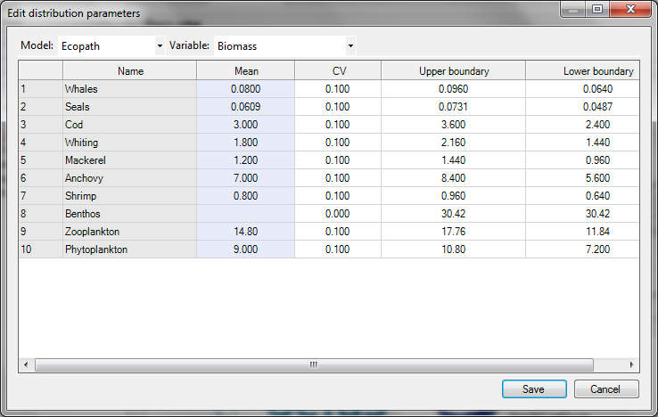
Figure 4.4. The form for editing the basic Ecopath and Ecosim distribution parameters

Step 4: Configuring the distribution parameters for basic Ecosim input parameters

Change the "Model" drop down box to "Ecosim" and ensure that the "Parameter" is set to "Dens. dep. catchability". There are two distributions that can be used for the basic Ecosim parameters (see 2.2.2 Ecosim Parameters: Sampling the Basic Ecosim Parameters), uniform and triangular. Specify which type you would like to use for each functional group along with the upper, lower and in the case of any specified as a triangular distribution, the mid-point values. Once you have completed this repeat which each of the other Ecosim parameters.

Once you have completed filling all the basic Ecopath and Ecosim parameters, click on "Save" to save the values to CSV file (Table 6.14.1).

Step 5: Configuring the survivability distribution parameters

Click on the "Survivabilities" button (Figure 4.3) to open the form for editing the survivability distribution parameters.
Error! Reference source not found.
Figure 3.3. The form for editing the survivabilities
For each fleet-prey combination specify alpha and beta values (see section Ecosim Parameters: Discard Survival Proportion) and click "Save" to save to CSV (Table 6.1, Appendix 3) and close the form.

Step 6: Editing the diet distribution parameters

Click on the "Diets..." button (Error! Reference source not found.Figure 4.3) to open the form for editing the diet distribution parameters (Figure 3.4Figure 3.4). Input the multipliers (see section 2.2.1 Ecopath Parameters: Sampling the Diet Matrix) for each predator and click "Save" to save to CSV (Table 6.1, Appendix 3) and close the form.

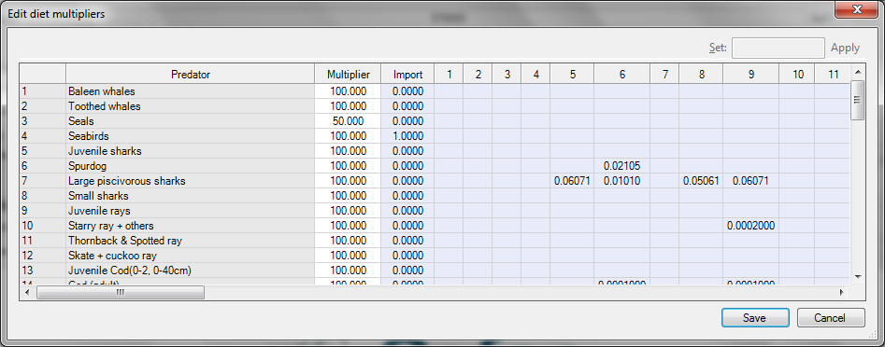
Figure 3.4. The form for editing the diet distribution parameters.

Step 7: Specify the area that the model represents

Edit the area field on the main form (Figure 4.3).

Step 8: Run the generation of models

Specify the number of models you want to generate on the main form (Figure 4.3). Each model will produce a unique result for each strategy that you create. Try a low number such as two to begin with, to see that the plug-in is working correctly. Later the number can be increased to something that will approximate the distribution of the results. Click on the play button (Figure 4.3) to start generating models (Table 6.2, Appendix 4).

Evaluate Management Strategies

Step 9: Configure the strategies

Step 9a: Open the strategies form
Click on the "Review" button (Figure 4.3) to open the form for configuring the strategies (Error! Reference source not found..
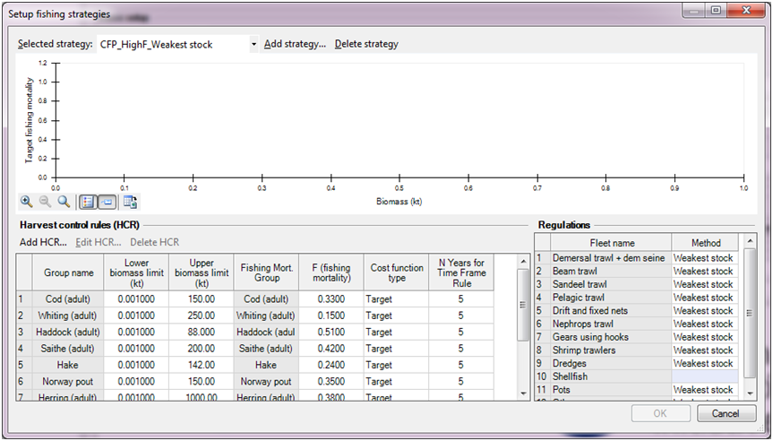
Step 9b
Step 9f
Step 9c
Step 9d
Step 9e
Step 9g
Step 9h

Figure 3.5. The form for editing strategies.

Step 9b: Adding strategies
Strategies (see section 2.3.1 The Management Loop: Determine the quota using the Harvest Control Rule (HCR)) can be added by clicking on the “Add Strategy” button (Figure 4.7). Give the strategy a name and click “OK”.

Step 9c: Adding Harvest Control Rules
Without harvest control rules the strategy will mean nothing, so the next task will be to add them to your strategy. Click on the “Add HCR” button (Figure 4.7). You will be presented with a form (Figure 4.8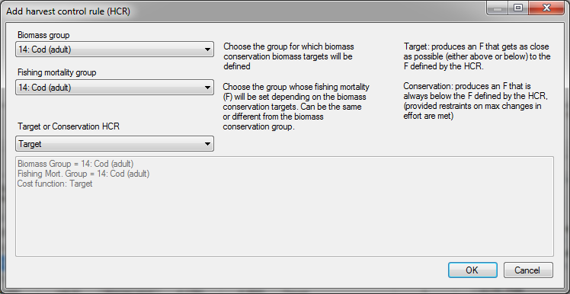Figure 3.6. The form for inputting basic HCR information
) requesting you to input some basic details for the HCR. Use the “Biomass Group” drop down box to choose the group whose biomass will determine the F and the “Fishing Mortality Group” drop down box to choose the group whose fishing mortality you want to control. In many cases the Biomass Group and Fishing Mortality Group will be the same, although in some circumstances, especially when setting up a conservation HCR, these functional groups may be different. The last thing you need to specify in this form is whether it is a target or conservation HCR.

Figure 3.6. The form for inputting basic HCR information

Step 9d: Specifying HCR reference points
Once a HCR has been created you need to specify its reference points. Select the HCR you have created in the list at the bottom of the window. Change the values either graphically by dragging the handles on the plot or by entering the values in the data grid at the bottom. If you want to apply a time frame rule set the number of years in "N Years for Time Frame Rule" to the number of years you want the changes in F to be applied over.

Step 9e: Deleting Harvest Control Rule
If you want to remove a HCR from a strategy it can be deleted by selecting it from the list and clicking on the “Delete HCR” button (Figure 4.7).

Step 9f: Deleting strategies
Similarly strategies can be deleted by selecting them from the drop down menu and clicking on the “Delete Strategy” button (Figure 4.7).

Step 9g: Configuring regulations
To configure the regulation settings for a Strategy click on the method field beside the fleet you want to specify the strategy for and pick one of the regulation methods (Figure 4.7).

Step 9h: Saving the Strategies
Once you are happy that you have configured all the strategies you want to evaluate correctly, click on the ok button (Figure 4.7) to save the settings to file (Table 6.3, Appendix 5) and close the form.

Step 10: Editing the maximum increase in effort values
Click on the “Max. Effort Increase...” to load up the “Edit maximum increase in fishing effort” form (figure 4.9) (see 2.3.1 The Management Loop: Determine max effort for the year). These values are the maximum percentage, in decimal format that the effort can increase within a year from the effort of the last time step in the previous year. Edit the values for each fleet and click "Save" to save the values to file (Table 6.3, Appendix 5) and close the form.

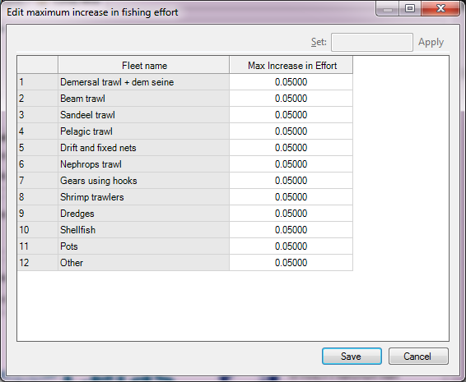
Figure 3.7. The form to edit the maximum increase in effort values.

Step 11: Configuring the stock recruit relationship used for the stock assessment (see section 2.3.1 The Management Loop: Perform stock assessment)
Click on the “Stock Assessment...” button to load the form for editing the stock recruitment parameters (Figure 4.10). If you would prefer not to include the stock assessment and observation uncertainty and instead permit that the biomasses applied to the HCRs be the actual biomass uncheck the "Use stock assessment model" checkbox. Alternatively ensure the checkbox is checked and set all the parameters for each functional group.

Click "Save" to save the values to file (Table 6.3) and close the form.
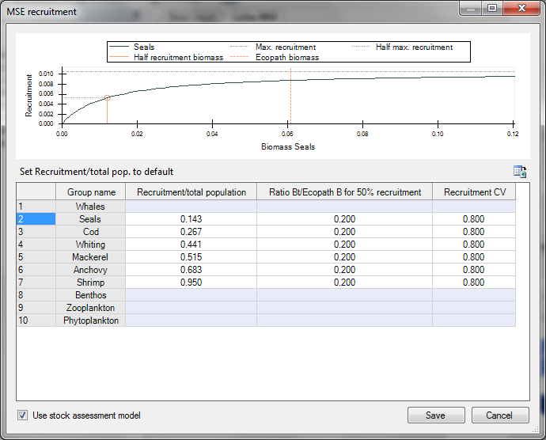
Figure 3.8. The form for configuring the stock assessment recruit relationship for the stock assessment.

Step 12: Setting the observation Error (see section 2.3.1 The Management Loop: Estimate a biomass from scientific surveys – the simulated ‘Survey Biomass’)
Click on “Assessment error...” to access the form for editing the Implementation and Observation Error (Figure 4.11). Ensure that "Biomass observation error" is chosen in the drop down box and set the CV's for each functional group.

Step 13: Setting the implementation error (see section 2.3.1 The Management Loop:

Add implementation error)
In the same form as that accessed in step 12 (Figure 4.11) choose "Fleet implementation error" in the drop down box and set the CV's for each fleet. Click save to save the values for both the observation and implementation error to file (Table 6.3, Appendix 5) and close the form.

Step 14: Setting the quota shares
(see section 2.3.1 The Management Loop: Determine the quota using the Harvest Control Rule (HCR))
Click on the "Quota Shares" button to access the form for editing the quota shares (Figure 4.12). Edit each of the quota share values. Note that values must sum to 1. To ensure this is the case click on the “Sum-2-One” button. This will distribute the values across all fleets with a non-zero value in proportion the values prior to clicking the button. Click "save" to save the values to file and close the form.

If the quota shares have not previously been configured defaults are used. The defaults can are calculated in one of two possible ways depending on whether Ecosim can be run on the base Ecopath model. If Ecosim can be run on the base Ecopath model the default share is:
$$q_{i,j}=\frac{L_{i,j}^{h}}{\sum_{jϵFleets}{L_{i,j}^{h}}}$$ | Equation 3-1

Where q is the quota share, and L^{h} is the landings at the end of the hindcast. If Ecosim cannot be run on the base Ecopath model the default share is:
$$q_{i,j}=\frac{L_{i,j}^{e}}{\sum_{jϵFleets}{L_{i,j}^{e}}}$$ | Equation 3-2

where Le is the landings in the base Ecopath fleet inputs.

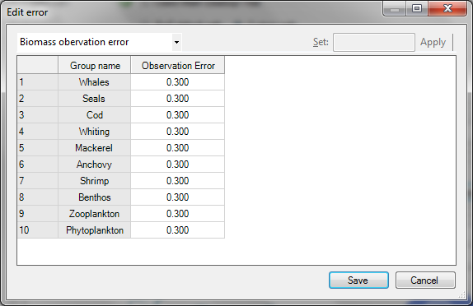Figure 3.9. The form for editing the observation and implementation error

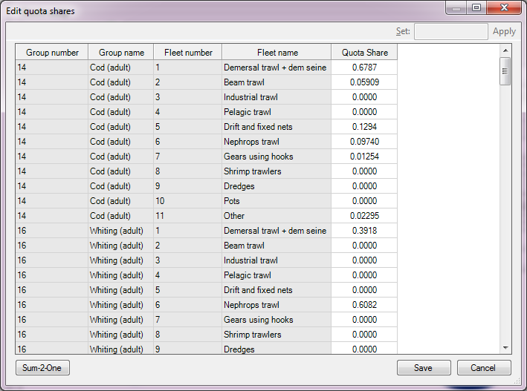Figure 3.10. The form for editing quota shares

Step 15: Setting up the Biomass Limits (see section 2.3.2 Screening the Results)

Click on the “Biomass Limits” button to load up the form to edit them. After you have edited the upper and lower limits for each group click “Save” to save the values for future runs.

Step 16: Resolving forcing function issues
There is a known issue in EwE when increasing the number of years to run the model; the forcing function values revert to some default value. This creates an undesirable step in the forcing function. This is an issue for the plug-in because it automatically extends the run by the number of years the user specifies. To resolve it, prior to running the plugin, taking care to note the initial number of years, extend the length of time for which to run Ecosim up to the maximum of 100 years by navigating to Ecosim->Input->Ecosim parameters and inputting 100 in “Duration of simulation (years)”. And then by navigating to Ecosim->Input->Forcing function you should be able to see any forcing functions that have a step at the year that the number of years was extended beyond. By clicking on the forcing function plot in the bottom window and clicking on the “Values…” option at the top of the window you can edit these values. Copy the very last value before the step to all subsequent time steps and then click “OK” to save. Repeat this process for all forcing functions. Finally reset the “Duration of simulation (years)” back to the number of years you recorded initially. Now when the plugin programmatically extends the number of years for the projection, the forcing function values used for those years will be as we have set them above and not include the step.

Step 17: Running the MSE

Choose the number of available models to run. Also set the number of years that you want the model to project forward; ideally this should be set to a value at which all the biomass trajectories have reached at equilibrium. To see if this is the case you will need to generate some results, plot them and see if the biomass trajectories have become flat. If you want to run for only a subset of the specified strategies click on “Select Strategies” and check/uncheck strategies accordingly. Finally click on the play button in the Run MSE panel. It may take quite a while to generate these results. If it takes too long to generate the results, you might want to consider either reducing the number of models or the number of years to project or both to make the length of time to run more practical. Once it has finished running your results will be in ../data/results.

To diagnose a problem it can often be useful to see the results regardless of whether they fail the biomass limits test or not. To do this expand the “Fishing” panel by clicking on “+” in the top right corner of the panel and click on the “Write all results” checkbox.

Managing results

Something that it is important to make you aware of is the volume of results that can be produced. Depending on the complexity of the model and the number of models you are using the produce results, the results can be anywhere from around 2GB right up to 60GB and beyond. Obviously this can be an issue, particularly if you generate more than one set of results. The size of the data folder can be reduced considerable by choosing to output only yearly results and in most cases these results will be adequate. You still might want to try running the model and viewing monthly results for a smaller subset of models to check that the behaviour of the model makes sense at a finer scale, but then once you are happy, and you are ready to run the model for a ‘complete’ set of models, it might make sense to choose the option to save only yearly results.

Another thing you can do to reduce the quantity of the results you are producing is to run the model for only a subset of your configured strategies. To do this, on the main form, click on the “Select strategies” button and check or uncheck the strategies as appropriate. An added benefit of doing this is that it can drastically reduce the plugins running time and this is can be helpful if you want to rapidly test one or two strategies and want to try different configurations/settings to see how they affect their performance.

Step 18: Viewing the results

You can view the data produced by the plug-in by opening the files located in ../data/results. There are two main result files at this location:

Table 4.1. Files that provide cross-sectional data for each model run.
File | Result variable name | Description of data | Units
Fleet.csv |  | The landings, discard survivals and discards for each group caught by each fleet in the final year. | Unit of weight/km²
Results.csv | BiomassMin | 1. The minimum biomass of each functional group across all projected time steps. | Unit of weight/km²
 | BiomassEnd | 2. The biomass at the very last time step | Unit of weight/km²
 | Landings | 3. The landings rate of each functional group at the final time step | Unit of weight/km²/year
 | DiscardMortalities | 4. The discard rate of each functional group at the final time step | Unit of weight/km²/year
 | DiscardSurvivals | 5. The rate at which each functional group is caught and survives at the final time step. | Unit of weight/km²/year
 | TotalEndValue | 6. The rate at which value is extracted from the catches of each functional group at the final time step. | Currency/km²/year

Additional results files can also be found in each of the folders found within ../data/results. See Table 4.2 for an explanation of the results found in each folder. In files with the prefix yearly, the results are calculated as the mean value across the year. Note that for catch, discards and landings the average rate over the year is the actual catch, discards and landings for the year.
Table 3.2. Files that provide Time-series results
Folder | Description of data | Units
Biomass | The biomass for each functional group at each time step from the beginning of the hindcast to the end of the projection | Unit of weight/km²
CatchTrajectories | The catch rate at each time step from the beginning to the end of the projection. | Unit of weight/km²/year
DiscardsTrajectories | The discard rate at each time step from the beginning to the end of the projection. | Unit of weight/km²/year
LandingsTrajectories | The landings rate at each time step from the beginning to the end of the projection. | Unit of weight/km²/year
Effort | The effort multiplier applied for each fleet at each time step from the beginning of the hindcast to the end of the projection
HCRF_Targ | The fishing mortality rate specified by a target HCR | /km²/year
HCRF_Cons | The fishing mortality rate specified by a conservation HCR | /km²/year
HCRQuota_Targ | The quota specified by a target HCR | Unit of weight/km²
HCRQuota_Cons | The quota specified by a conservation HCR | Unit of weight/km²
HighestValueGroups.csv | The highest value group for each year and each fleet of each run. This only applies for the highest value and selective regulation strategies. | Name of the group that is highest value
ChokeGroups.csv | The choke group for each time step and each fleet of each run. The choke group is the group that requires the least effort to catch its quota. This only applies to weakest stock regulation strategies. | The name of the group that is the choke group
RealisedF | The actual fishing mortality rate that is applied to each group for each time step of the projection | /km²/year
RealisedLandedF | The actual fishing mortality due to landings that is applied to each group of each run for each time step of the projection | /km²/year
RealisedDiscardedF | The actual fishing mortality due to discards that is applied to each group of each run for each time step of the projection | /km²/year
ValueTrajectories | The rate at which monetary value is extracted by the catch of each fleet functional group combination for each time step of the projection. | currency/km²/year

If you have unwanted results that you would like to remove from the file structure, click on the "Delete results" button on the main form.

Step 19: Plotting and displaying results
To make the results more meaningful you will want to plot them. We have developed a repository of R code for this purpose, and although this has not been designed to be used by others, you are free to download and make use of the code. This repository can be accessed at:

https://github.com/MarkPlatts/MSE_Plugin_Results_Plotting/

We have worked with stakeholders on developing a simple format for two way comparisons of alternative strategies, with information to express the risk associated with the strategies performance (Figures 4.13 & 4.14).

Note in particular that the plots express

- user specified reference points for B_{pa} and B_{lim}
- risk of exceeding ref limits as a measure of risk
- lower and upper quartiles because these help to express uncertainties and compare them between strategies

See also Figures 4.15 – 4.22 for illustrations of other additional plots and tables that can be created using R. The plots here are only a small subset of the possible plots that can be created and their purpose is to be used to explore the results and not as final quality plots for publications. Also note that not all code for these plots can be found at the above GitHub address and in some cases changes might have been made to the code that affect how the plots are displayed.

Figure 3.11. Illustrative example of the species-focussed results, communicating risk in relation to exceeding limits. Results for many species can be compared so ecological trade-offs and winners and losers can be identified.

Figure 4.14. Illustrative example of the fleet-focussed results, where fleet trade-offs among alternative strategies can be identified
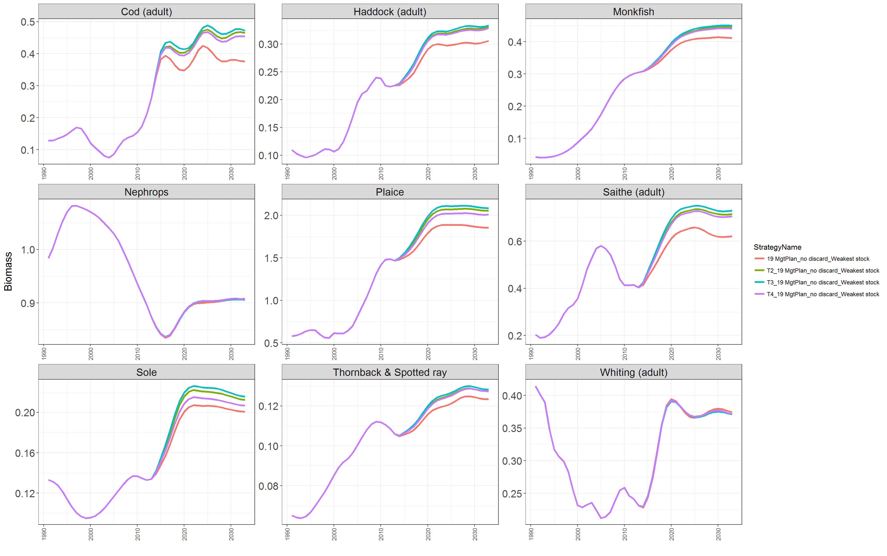
Figure 4.15. Plot created using R code that illustrates how time series can be displayed for many groups and to compare between strategies.
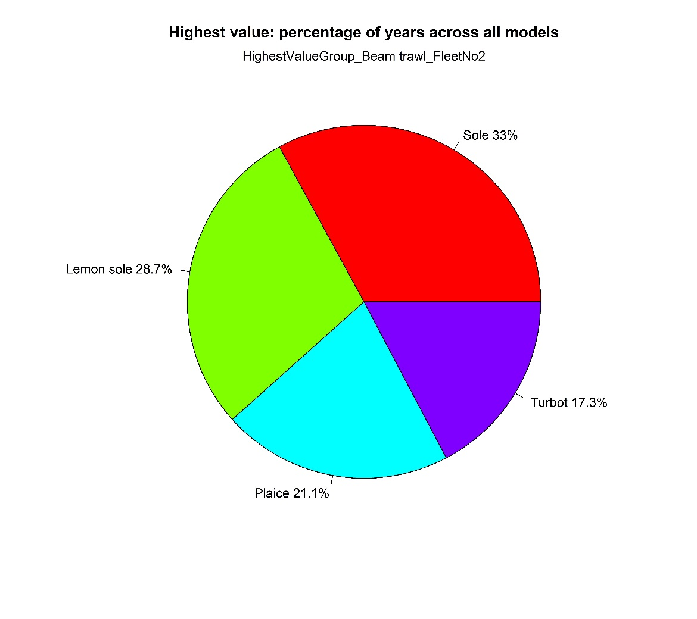
Figure 4.16. Plot created using R code that shows the percent of the time steps for which each species was a highest value across all models.
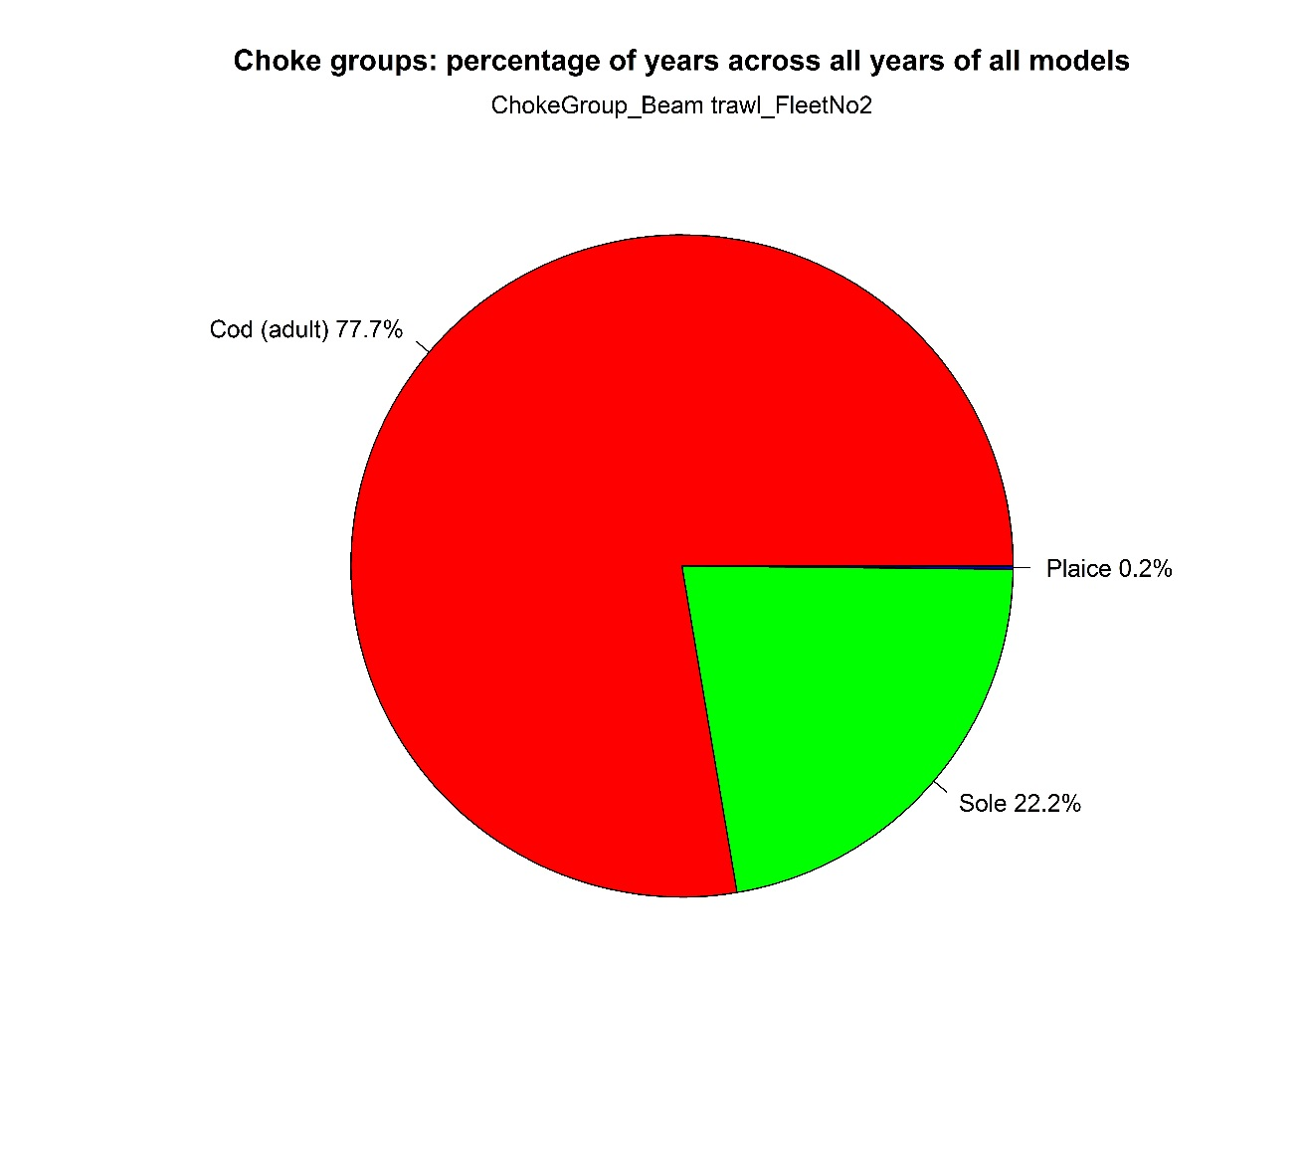
Figure 4.17. Plot created using R code that shows the percent of the time steps for which each species was a choke species across all models.

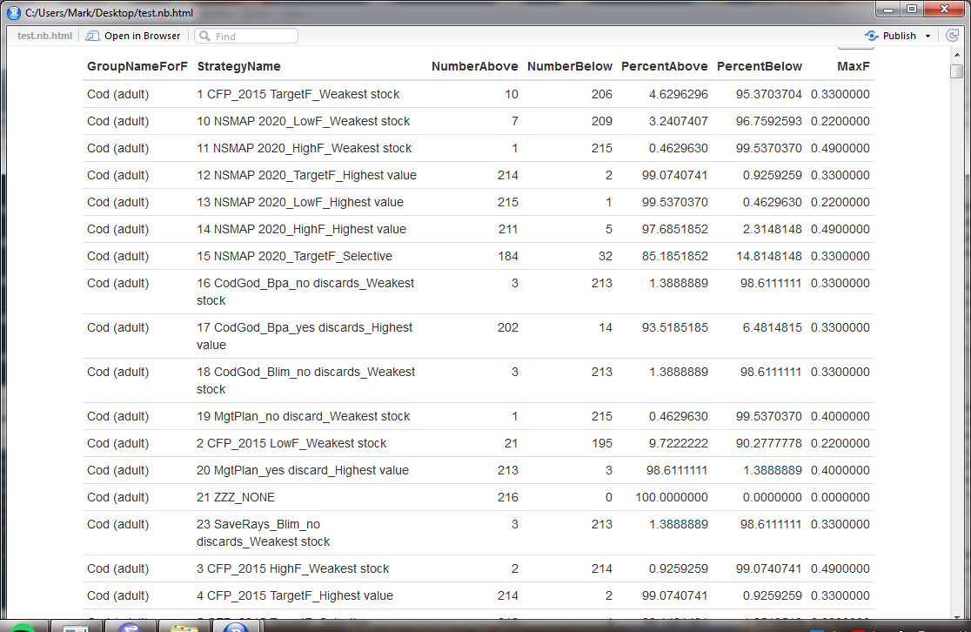
Figure 4.18. Table created using R code showing the percent of models for which last 5 year mean F was below or above Max F for the given strategy.

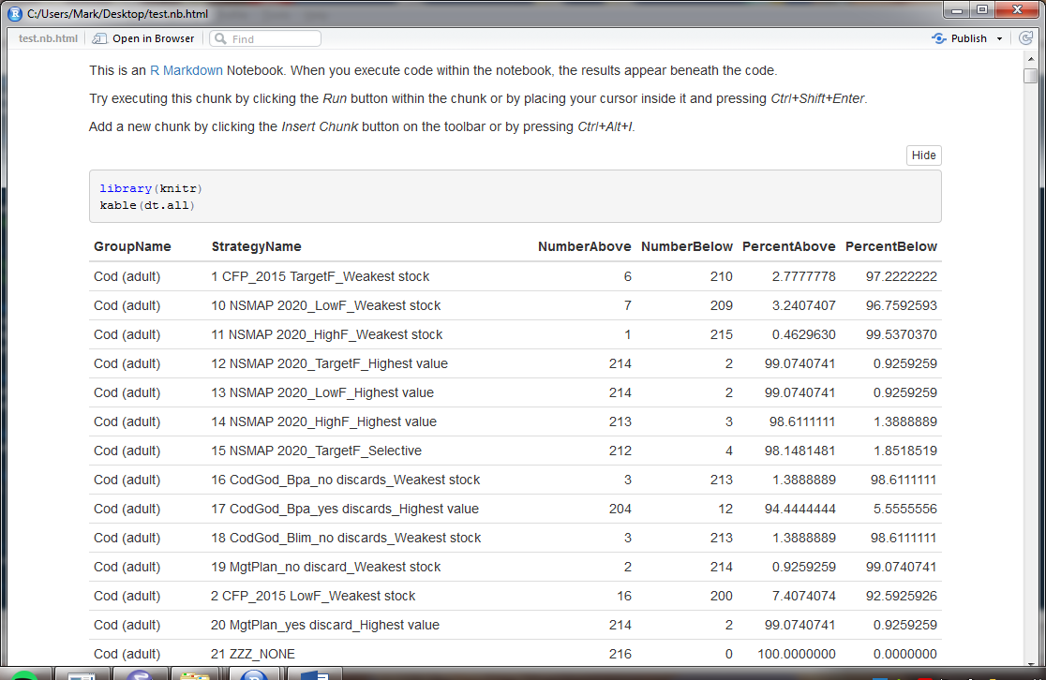
Figure 4.19. Table created using R code showing the percentage of models that were above and below the mean quota of the last 5 years

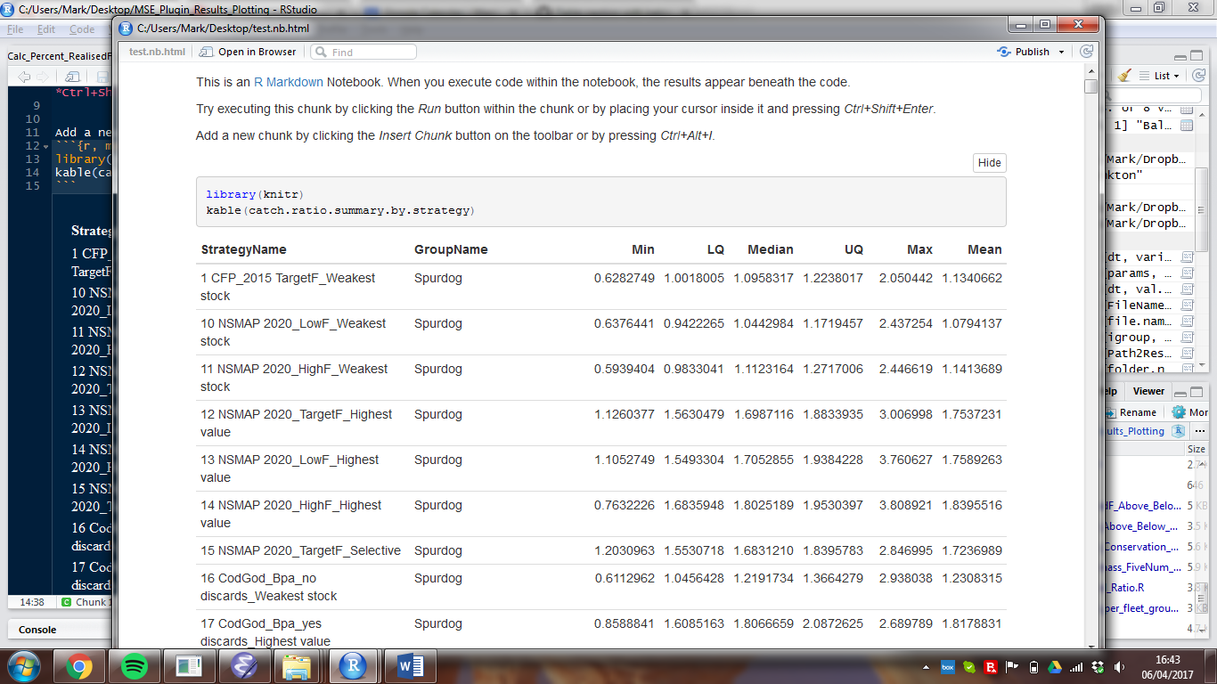
Figure 4.20. Table created using R code showing the 5 number summary and mean for the catch start to last 5 year mean ratio.

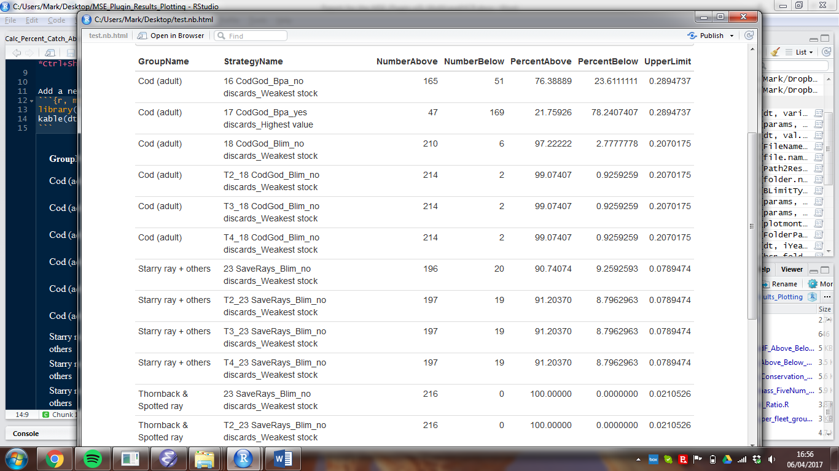
Figure 4.21. Table created using R code which shows the percentage of models for which the last 5 year mean biomass was below the upper conservation HCR biomass limit.

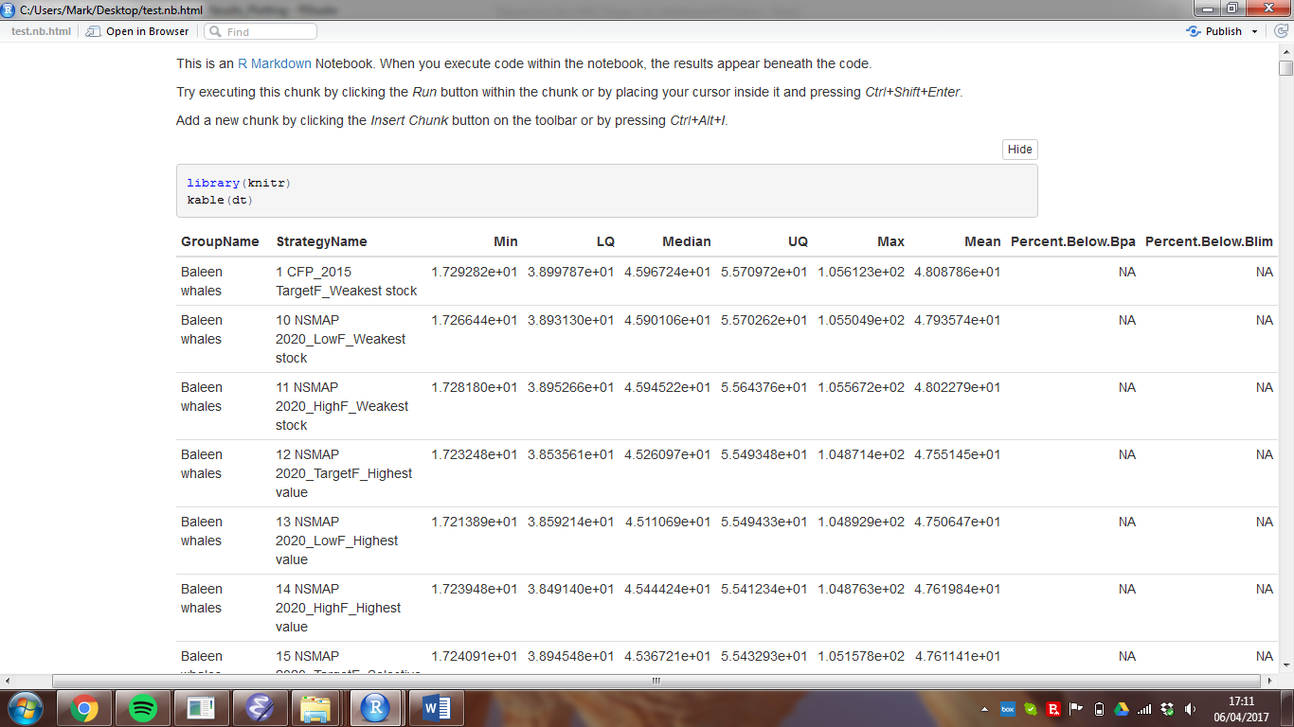
Figure 4.22. Table created using R code which shows the five number summary, mean and percentage above and below Bpa and Blim for the last 5 year mean biomass.

Limitations and assumptions of the tool

Because the plug-in depends on the modelling framework provided by EwE, most if not all of the assumptions and limitations of this framework can be applied to the assumptions and limitations of the plug-in. One important limitation is the way in which EwE handles the recruitment process. Predicting recruits is notoriously difficult, and many MSEs don't try, but instead treat the process as entirely random. Doing so, handles the recruit process as if it is another element of uncertainty and makes good sense in an MSE context; however, EwE provides no such functionality to do this and without it we simply have to assume that the mechanisms which it does provide for recruits are true and accurate, which they are not. As a consequence we cannot be sure that the management strategies are robust to uncertainty in the recruit process.

The parameter distributions are formed entirely from expert opinion and where available, supporting data. These distributions are sampled using a Monte Carlo approach. No effort is made by the plugin to condition these parameter distributions on data, such as biomass time series, as you would when taking a Bayesian approach. While we recognise that it is desirable to condition based on data, since Ecopath with Ecosim uses so many parameters a real problem of overfitting arises. Furthermore we believe that to perform such an analysis the computer processing time would be excessive if not beyond feasible. And therefore it is for these reasons the simpler Monte Carlo approach has been applied. As a consequence we suggest that it would not be sensible to use the output from the plugin to make precise predictions for the future. Rather we propose that the results should be used to rank the performance of several strategies and that the results to be supportive evidence rather than conclusive.

For more complex EwE models, it can be difficult to sample parameters that are mass-balanced. In such cases the only way to find them is to reduce the dispersion of the distributions from which the parameters are drawn. This compromises the integrity of the approach. Possibly a better idea, although still not ideal, would be to allow the distributions to be curtailed and then provide with the results what the likelihood is that the range of sampled models will contain the real model and the likelihood that the reality will be a system outside the range of sampled models. Also to address this issue, we would like to consider more ingenious methods of finding mass-balanced models, while allowing the probability distributions from which they are drawn to still have meaning.

Example and application
A video walkthrough of a worked example using the simple Anchovy Bay training model has been developed and can be made available on request. We hope to improve this and make it available via the Ecopath website.

A detailed application of an earlier version of the routine has been used in the evaluation of European commission proposals for a North Sea Multi-annual management plan. The report can be found here:

http://stecf.jrc.ec.europa.eu/web/stecf/ewg1502

Mackinson et al. (in prep) provides a demonstration application by evaluating the implications of the proposed North Sea multi-annual plan (EC 2016/0493).

Appendices

Appendix 1. Inventory of input distribution parameter files
The distribution parameter files created and used by the plug-in can be found in <path to the root data directory>/DistributionParameters/. These files contain input parameters that you must configure as described in steps 3-6 of the user manual. Using the defaults is not adequate and will generate erroneous results.

Table 6.1. Distribution parameters
Parameter Name | File Name | Distribution parameters
Biomass | B_Dist.csv | CV, upper and lower bounds
Biomass accumulation | BA_Dist.csv | CV, upper and lower bounds
Ecotrophic efficiency | EE_Dist.csv | CV, upper and lower bounds
Production/Biomass | PB_Dist.csv | CV, upper and lower bounds
Consumption/Biomass | QB_Dist.csv | CV, upper and lower bounds
Density dependent catchability | DenDepCatchability.csv | Either (a) Uniform(Upper and lower bounds)  or (b) Triangular(Midpoint, upper and lower bounds)
Feeding time adjust rate | FeedingTimeAdjustRate.csv | Either (a) Uniform(Upper and lower bounds)  or (b) Triangular(Midpoint, upper and lower bounds)
Maximum relative feeding time | MaxRelFeedingTime.csv | Either (a) Uniform(Upper and lower bounds)  or (b) Triangular(Midpoint, upper and lower bounds)
Fraction of other mortality sens. to changes in feeding time | OtherMortFeedingTime.csv | Either (a) Uniform(Upper and lower bounds)  or (b) Triangular(Midpoint, upper and lower bounds)
Predatory effect feeding time | PredEffectFeedingTime.csv | Either (a) Uniform(Upper and lower bounds)  or (b) Triangular(Midpoint, upper and lower bounds)
QBmax/QBo | QBMaxxQBio.csv | Either (a) Uniform(Upper and lower bounds)  or (b) Triangular(Midpoint, upper and lower bounds)
Switching power | SwitchingPower.csv | Either (a) Uniform(Upper and lower bounds)  or (b) Triangular(Midpoint, upper and lower bounds)
Diet composition multipliers | DietCompositionMultipliers.csv | Multiplier (κ)
Survivabilities | Survivabilities_dist.csv | α,β

Appendix 2. ParametersOut
These are the values that have been sampled from the specified distributions and tested to be mass-balanced and can be found in <path to the root data directory>/ParametersOut/

Table 6.2. ParametersOut
Parameter Name | File Name | File description
Biomass | b_out.csv | Values for Ecopath biomass are given for each functional group by column. Each row specifies the biomass values for a unique model.
Biomass accumulation | ba_out.csv | Values for Ecopath biomass accumulation are given for each functional group by column. Each row specifies the biomass values for a unique model.
Ecotrophic efficiency | ee_out.csv | Values for Ecopath ecotrophic efficiency are given for each functional group by column. Each row specifies the biomass values for a unique model.
Production/Biomass | pb_out.csv | Values for Ecopath production/biomass are given for each functional group by column. Each row specifies the biomass values for a unique model.
Consumption/Biomass | qb_out.csv | Values for Ecopath consumption/biomass are given for each functional group by column. Each row specifies the biomass values for a unique model.
Density dependent catchability | DenDepCatchability_out.csv | Values for Ecosim Density dependent catchability are given for each functional group by column. Each row specifies the biomass values for a unique model.
Feeding time adjust rate | FeedingTimeAdjustRate_out.csv | Values for Ecosim Feeding time adjust rate are given for each functional group by column. Each row specifies the biomass values for a unique model.
Maximum relative feeding time | MaxRelFeedingTime_out.csv | Values for Ecosim Maximum relative feeding time are given for each functional group by column. Each row specifies the biomass values for a unique model.
Fraction of other mortality sens. to changes in feeding time | OtherMortFeedingTime_out.csv | Values for Ecosim Fraction of other mortality sens. to changes in feeding time are given for each functional group by column. Each row specifies the biomass values for a unique model.
Predatory effect feeding time | PredEffectFeedingTime_out.csv | Values for Ecosim Predatory effect feeding time are given for each functional group by column. Each row specifies the biomass values for a unique model.
QBmax/QBo | QBMaxxQBio_out.csv | Values for Ecosim QBmax/QBo are given for each functional group by column. Each row specifies the biomass values for a unique model.
Switching power | SwitchingPower_out.csv | Values for Ecosim Switching power are given for each functional group by column. Each row specifies the biomass values for a unique model.
Diet composition matrix | DietMatrixTrialX.csv | Values for each models diet matrix are stored within a unique file, where X denotes the model number
Survivabilities | Survivabilities_out.csv | Values are given for each fleet & functional group combination for each model. Note that the number for iteration is the number of the model
Vulnerabilities | VulnerabilityIterationX_out.csv | Values for model X are given for each predator prey combination where each row represents the predator index and each column the prey index.

Appendix 3. Settings for evaluation of management strategies

Table 6.3. Settings for evaluation of management strategies
Name | Filename & Path | File description
Biomass | <path to the root data directory>\BiomassLimits\BiomassLimits.csv | The first column species which functional group the limits are specified for and then the second and third columns specify what those limits are
Maximum change in effort | <path to the root data directory>\Fleet\ChangesInEffortLimits.csv | For each fleet in decimal format the maximum percentage change in effort that is allowable between any value in a given year and the value at the last time step of the previous year.
Quota shares | <path to the root data directory>\Fleet\QuotaShares.csv | For each group that has a hcr, in decimal format, the percentage of the quota is specified that each fleet is allocated.
HCRs | <path to the root data directory>\HCRs\ | Each file specifies all the HCRs for one strategy.
Regulations | <path to the root data directory>\Regulations\ | Each file specifies the regulations for each fleet that catches a functional group with a quota for one strategy.
Observation error | <path to the root data directory>\StockAssessment\StockAssessment.csv | These are specified under the column entitled Biomass_Observation_Error
Implementation error | <path to the root data directory>\StockAssessment\StockAssessment.csv | These are specified under the column entitled FleetImplementationError
Stock assessment parameters | <path to the root data directory>\StockAssessment\StockAssessment.csv | Parameters for the stock-assessment are found in the top half of this file beside the Biomass observation errors. Note that the Kalman error is a value used by the stock assessment routine but it does not have an interface for changing it.
Stock assessment output | <path to the root data directory>\StockAssessment\BobsOverB.csv | All the values in this file are predicted stock assessment biomass/ ecosim biomass. These values can be used to see how much the stock assessment method over or under predicts the actual biomass.

Appendix 4. Ideas for fleet behaviours
The model currently applied for fleet behaviour is fairly basic and it is recognised that a more sophisticated and accurate model would be a valuable improvement to the plug-in. However, fleet behaviour is a complex subject and very difficult to model well. Here we propose a model for consideration in future developments. Although not perfect, we believe it could be a considerable improvement.

The proposition is to allow fleets to fish in one of several states. Each state is characterised by different values of F for each species within its catch composition. The fleet can then choose which state to fish in and makes this decision contingent on what state will derive the fleet the greatest catch or profit for a given year. This will bring us closer to the true dynamics in fleet fishing patterns when faced with a no-discard policy; here fleets may want to avoid catching certain species to avoid reaching their allotted quota.

The degree to which a fleet can alter the F’s of each species is highly uncertain. For this reason we propose that the F’s of each mode be sampled from a probability distribution, which represents this uncertainty. As with uncertainty in the Ecopath and Ecosim parameters, all modes of all fleets are sampled and assigned to a model for a possible representation of reality.

Appendix 5. Symbols for parameters
Parameter symbol | Parameter name / description
κ | Multiplier for the dirichlet distribution
x | Generic Sampled Parameter
a | Lower bound for the uniform and triangular distributions
b | Upper bound for the uniform and triangular distributions
c | The mode for triangular distributions
U | Standard Uniform Random Variable
m(d) | Proportion of discards that die
m(c) | Proportion of catch that dies
$$m_{i,j}^{l}$$ | Proportion of catch that is landed
i | Index for the group
j | Index for the fleet
s | Proportion of discards that survive
P | Shape parameter for beta-distribution
Q | Shape parameter for the beta-distribution
μ | Mean
$$v$$ | Vulnerability
r | Predator index
k | Prey index
B | Biomass
$$K_{t}^{*}$$ | Kalman gain
g | Combined Deriso-Schnute growth and survival rate
t | Timestep
C | Catch
L | Landings
D | Discards
C^{L} | Catch to land quota
C^{S} | What the catch would have been if same effort was applied but the fleet was not selective
w | Weight at recruitment
R | Recruitment
α | Growth constant for g
ρ | Growth constant for g
S | Natural survival rate
B_{min} | HCR Biomass at which F=0
F | Fishing Mortality Rate
B_{max} | The biomass at which F=Fmax
F_{max} | The maximum Fishing Mortality in the HCR
l^{prev}_{j} | Effort in the last time step of the previous year
l^{max}_{j} | The max possible effort during the given year
$$λ$$ | The maximum percentage change in effort for any effort in current year from the effort in the final time step of the previous year
q | Quota share
$$q_{i}^{T}$$ | Target quota
$$q_{i}^{C}$$ | Conservation quota
M | QMult
d | Max. recruits possible
e | Stock needed to produce a/2
ζ | Recruitment/total population
η | Ratio Bt/Ecopath? B for 50% recruitment
ϕ | Recruitment CV

Appendix 6. Unusual behaviours explained
In this section unusual behaviours observed in the results will be discussed. The aim here is to provide an understanding why certain unusual behaviours are occurring so that a decision can be made as to whether this behaviour is acceptable or not and what courses of action are be available to modify such behaviour.

Big drops in efforts

- In section 2.3.1 The Management Loop: .
Time Frame Rules it was stated that huge drops in quota from one year to the next are often considered undesirable and that one way to address this issue was by using a time frame rule. In most cases this will often soften the decline in the effort, however in cases where a conservation rule has been applied this is not necessarily the case. Conservation rules cannot be configured to apply a time frame rule and can lead to an abrupt decline in the quota for a particular group. Should such declines be observed in the HCRF Cons files, and are believed to be undesirable, consideration should be given as to whether the conservation HCR is too draconian and if so, you need to decide whether to either remove it entirely or configure the biomass limits and maximum F values in such a way as to soften its impact on the results.

References
EC 2016/0493. Proposal for a REGULATION OF THE EUROPEAN PARLIAMENT AND OF THE COUNCIL on establishing a multi-annual plan for demersal stocks in the North Sea and the fisheries exploiting those stocks and repealing Council Regulation (EC) 676/2007 and Council Regulation (EC) 1342/2008.
Gaichas, S. K., Odell, G., Aydin, K. Y., and Francis, R. C. 2012. Beyond the defaults: Functional response parameter space and ecosystem-level fishing thresholds in dynamic food web model simulations. Canadian Journal of Fisheries and Aquatic Sciences, 69:2077–2094.
Kell, L. T., Mosqueira, I., Grosjean, P., Fromentin, J-M., Garcia, D., Hillary, R., Jardim, E., Mardle, S., Pastoors, M. A., Poos, J. J., Scott, F., and Scott, R. D. 2007. FLR: an open-source framework for the evaluation and development of management strategies. ICES Journal of Marine Science, 64:640–646.
Mackinson, S. Platts, M., Hadeler, S., Garcia, C., and Lynam, C. in prep. Evaluating the fishery and ecological impact of the proposed North Sea multi-annual plan and European MSY policy.
Schnute, J. 1985. A general theory for analysis of catch and effort data. Canadian Journal of Fisheries and Aquatic Sciences, 42:414-429.
Walters, C. 2004. Simple representation of the dynamics of biomass error propagation for stock assessment models. Canadian Journal of Fisheries and Aquatic Sciences, 61: 1061–10.

